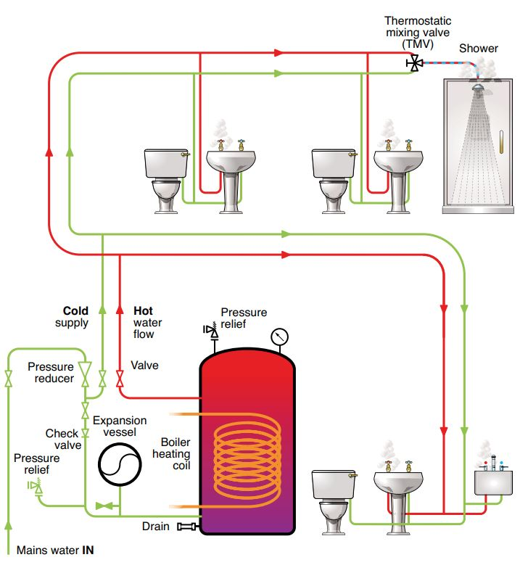

**Pressurised mains-fed system with non-recirculating hot water distribution**

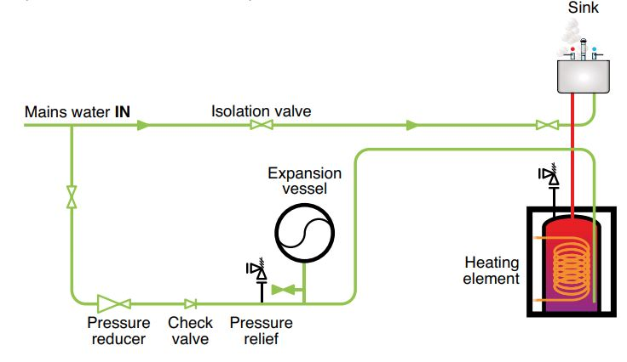

**Low storage volume POU water heater**

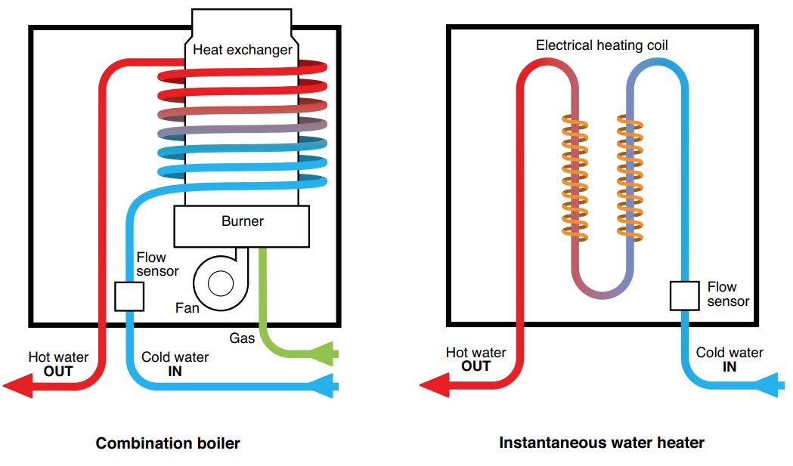

**Non storage water heaters**

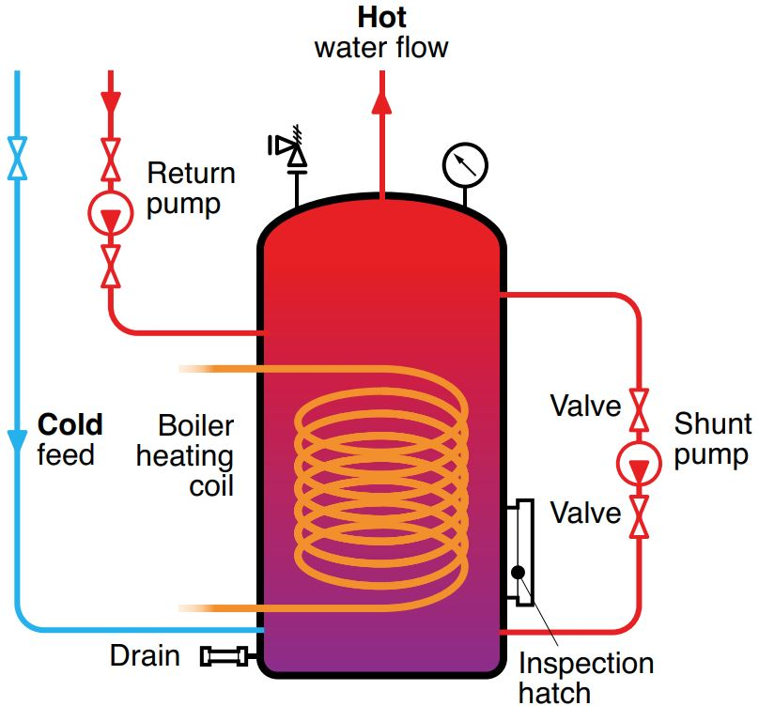

**Indirect heating calorifier vessel**

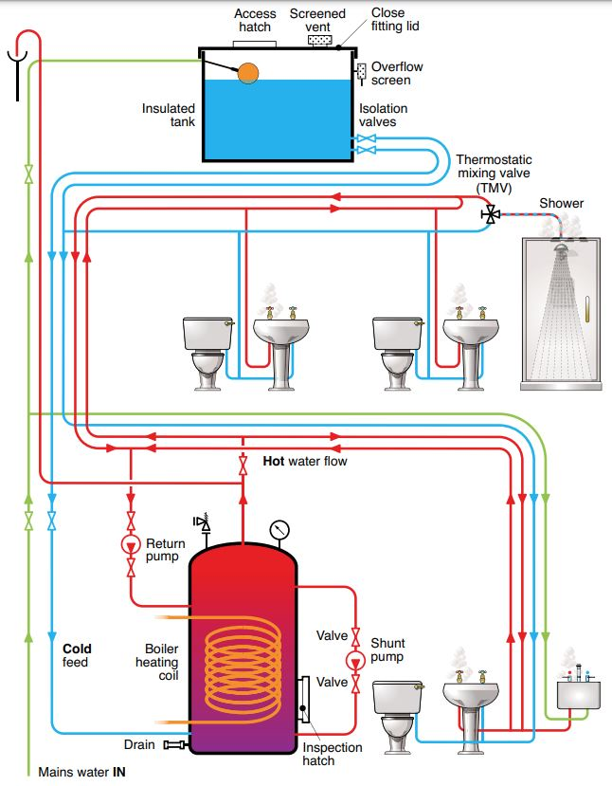

**Gravity fed system with recirculation**

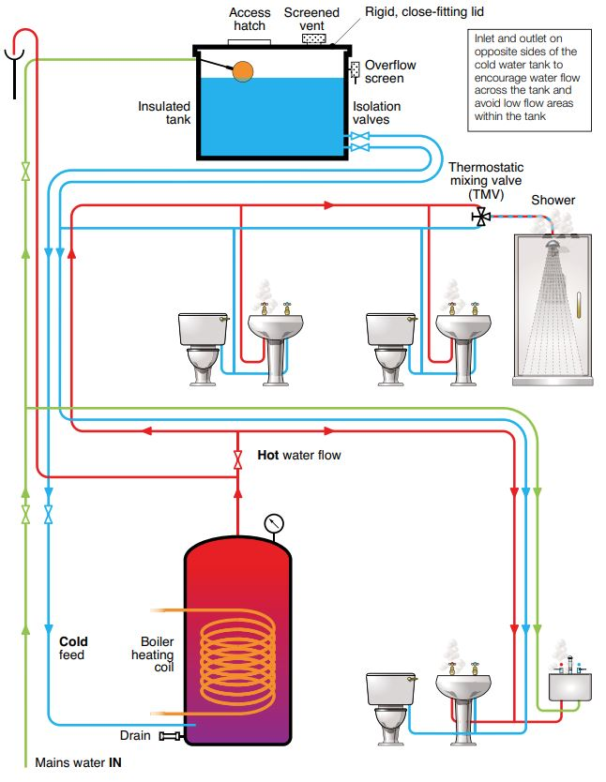

**Gravity fed hot & cold water system without recirculation**

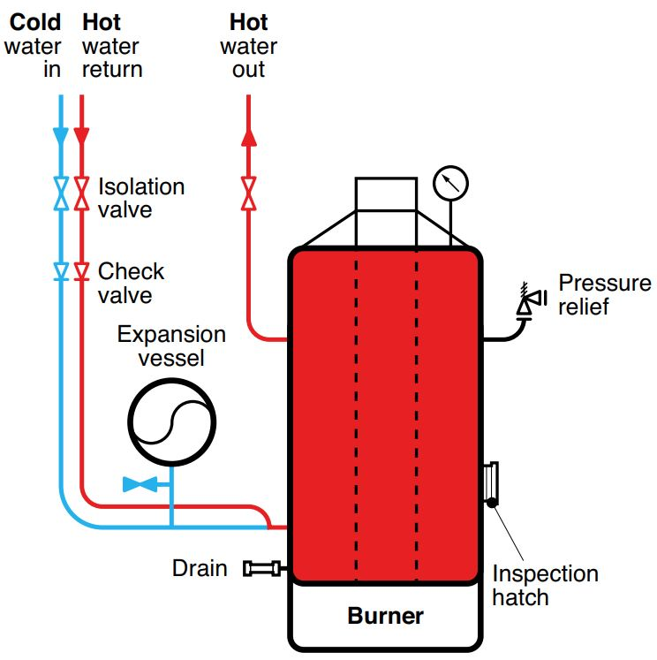

**Direct-fired (gas) water heater**

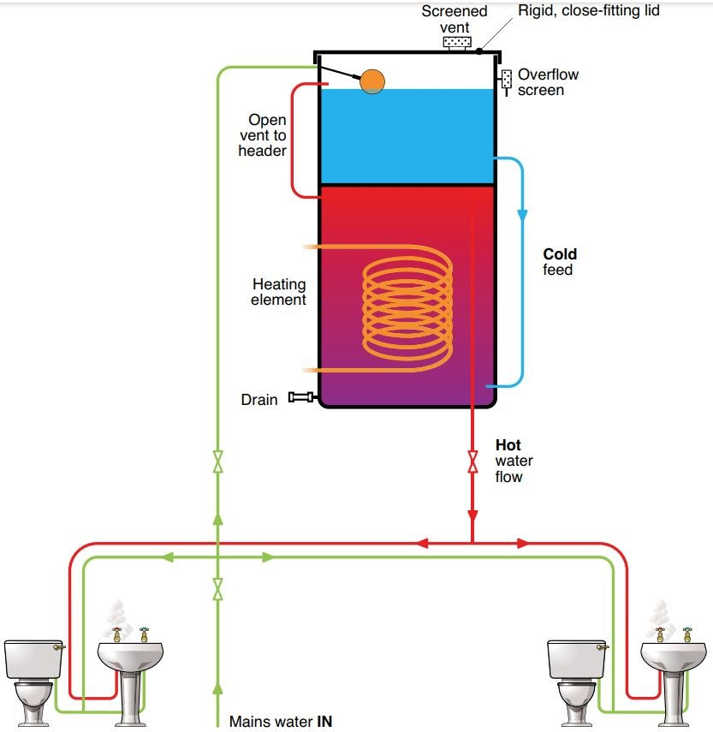

**Combination water heater**

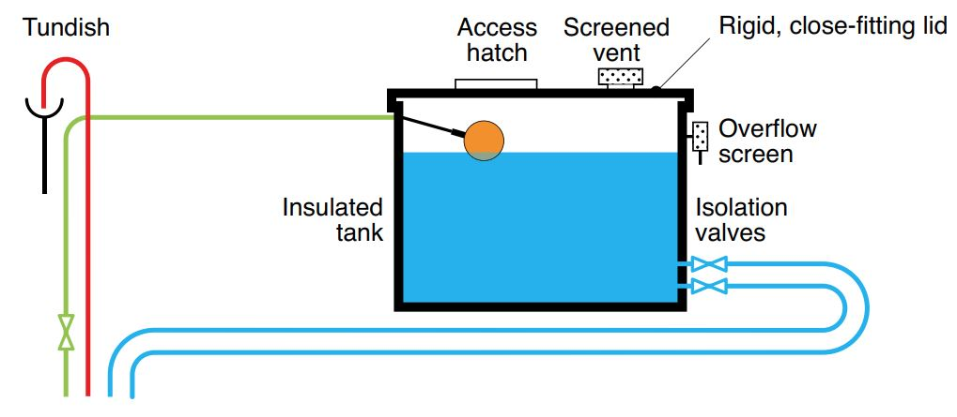

**Acceptable tank design**

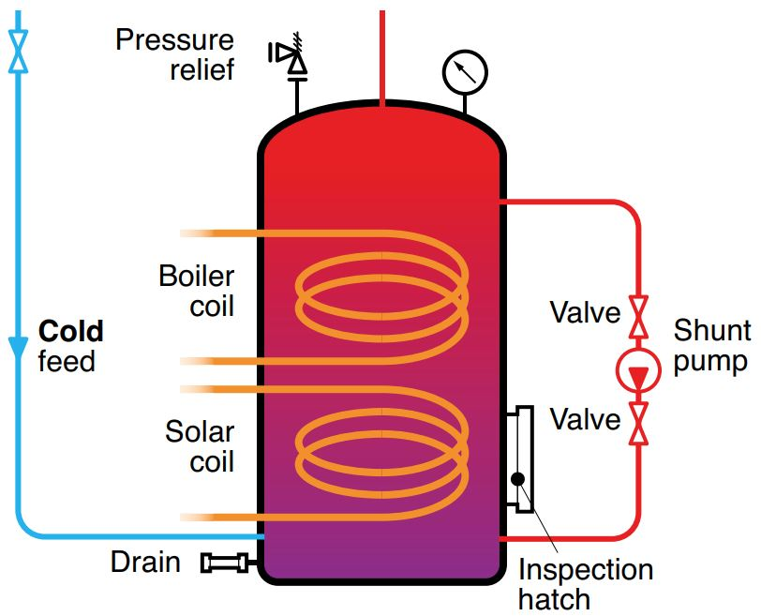

**Solar-heated calorifiers**

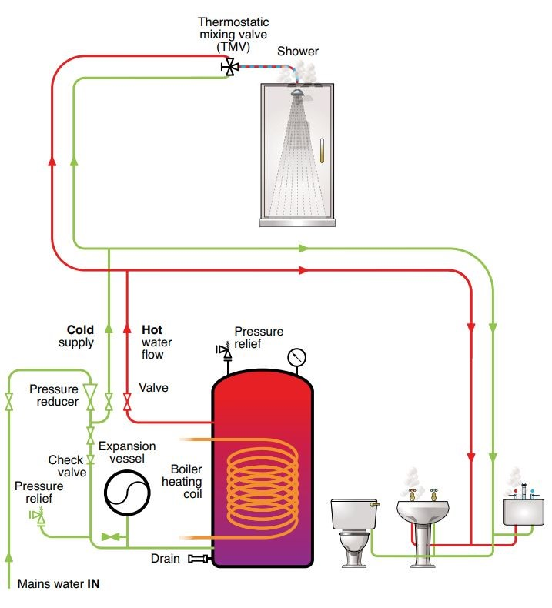

**35 EP pressurised mains-fed system with non-recirculating hot water distribution**

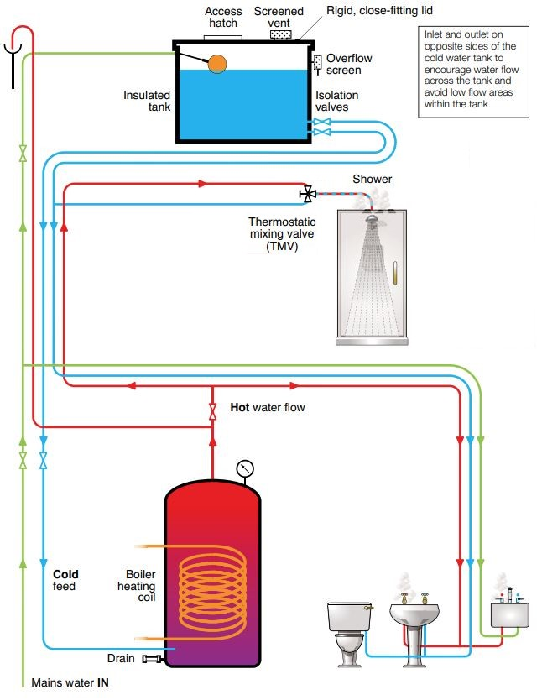

**EP & TR gravity fed hot & cold water system without recirculation**